Предлог поена:

Коначно поена:

Интернет језици и алати 2

Предспитни пројекат 1

Вељко Маринков ВД22/21

**Питања:**

**Кратак опис:**

**Ово је сајт на коме можете претражити текстове песама, за сад је избор приличко узак. Сајт је узет из ИЈА1 и модификован (додат је јаваскрипт).**

**На сајту постоји претрага која вас шаље на одређену страницу када је претражите, постоје дугмад за мењање теме, постоји форма за контакт.**

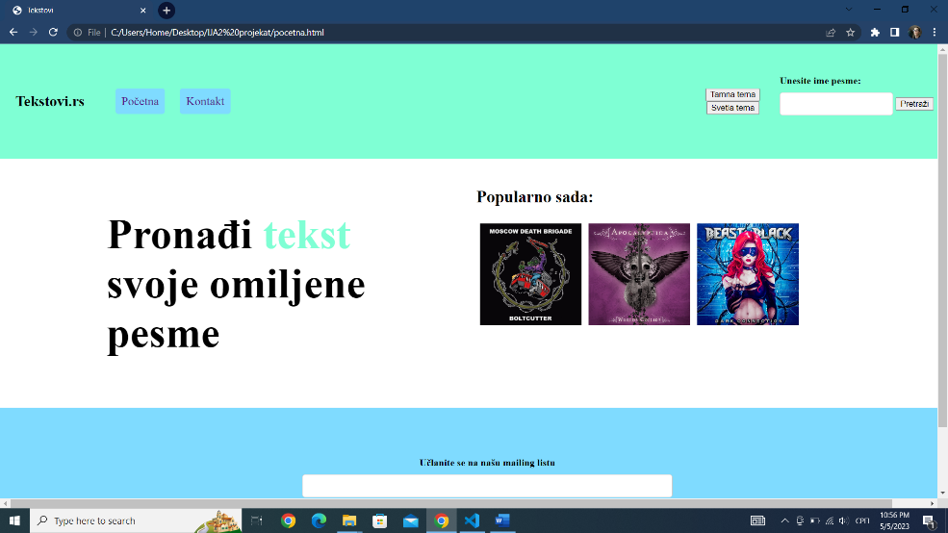

слика

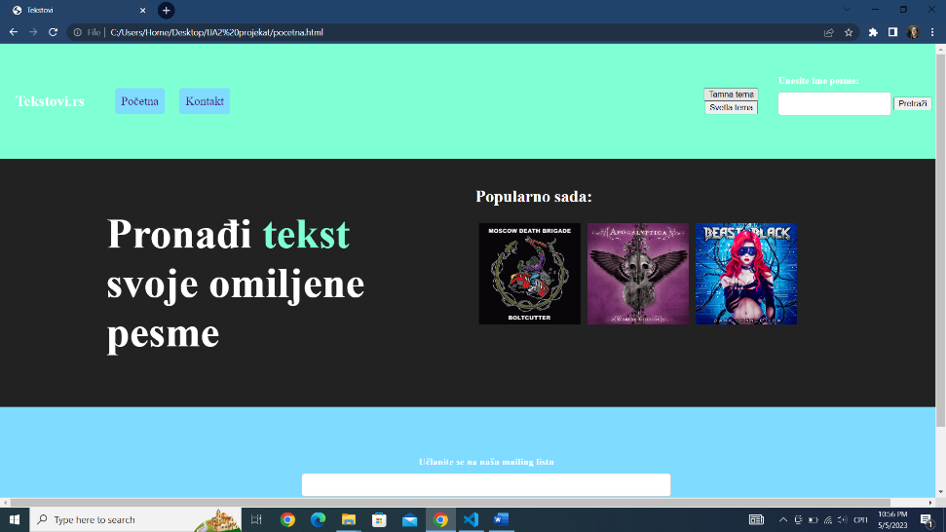

слика

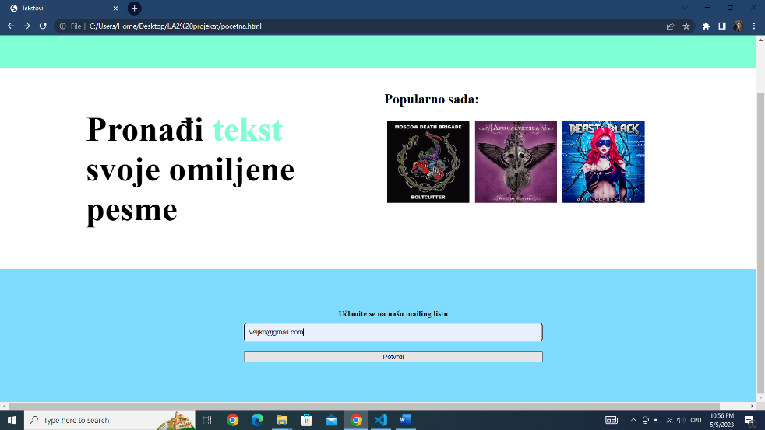

слика

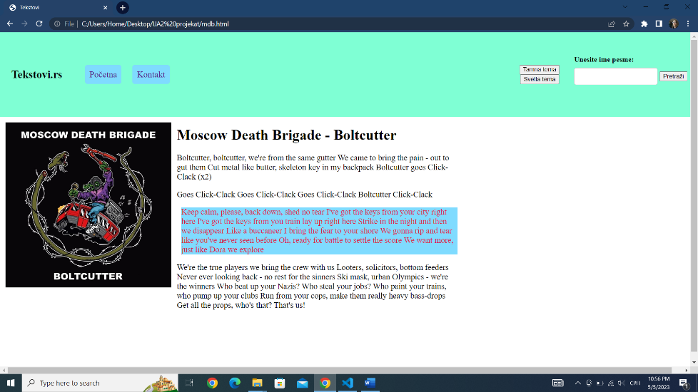

слика

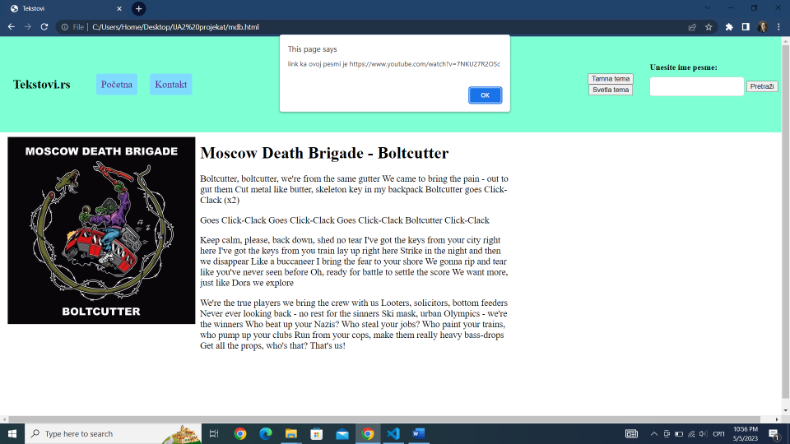

слика

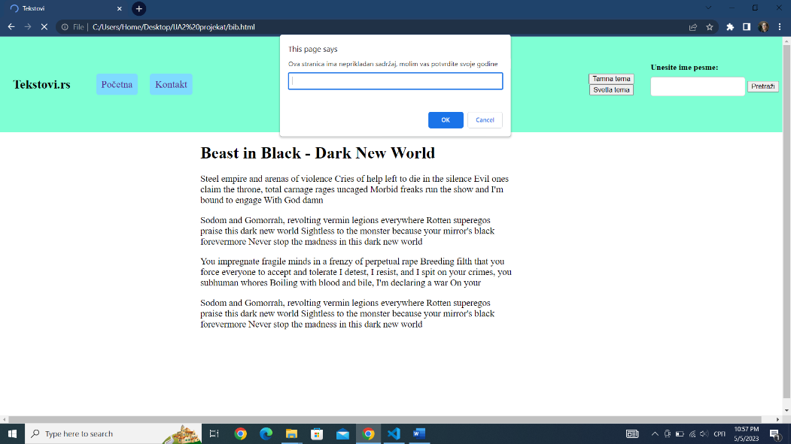

слика

**Код:**

**HTML**(*pocetna.html*)

<!DOCTYPE html>

<html lang="en">

<head>

    <meta charset="UTF-8">

    <meta http-equiv="X-UA-Compatible" content="IE=edge">

    <meta name="viewport" content="width=device-width, initial-scale=1.0">

    <title>Tekstovi</title>

    <link rel="stylesheet" href="stil.css">

</head>

<body>

    <nav id="navbar">

        <h1>Tekstovi.rs</h1>

        <ul>

            <li><a href="pocetna.html">Početna</a></li>

            <li><a href="kontakt.html">Kontakt</a></li>

        </ul>

        <div class="button-group">

            <button onclick="menjajTemu('tamna')">Tamna tema</button>

            <button onclick="menjajTemu('svetla')">Svetla tema</button>

        </div>

        <form onsubmit="return pretraziPesme();">

            <label for="pesma">Unesite ime pesme:</label>

            <div id="pretraga">

                <input type="text" id="pesma" name="pesma" required>

                <button type="submit">Pretraži</button>

            </div>

        </form>

    </nav>

    <div class="container">

        <div class="naslov">

            <h2>Pronađi <span> tekst </span> svoje omiljene pesme</h2>

        </div>

        <div class="popularnosada">

            <h2>Popularno sada:</h2>

            <div class="slike">

                <a href="mdb.html">

                    <div class="slika slika1"></div>

                </a>

                <a href="idc.html">

                    <div class="slika slika2"></div>

                </a>

                <a href="bib.html">

                    <div class="slika slika3"></div>

                </a>

            </div>

        </div>

    </div>

    <footer>

        <form id="email-form">

            <label for="email-input">Učlanite se na našu mailing listu</label>

            <input type="email" id="email-input" required>

            <button type="submit">Potvrdi</button>

        </form>

    </footer>

    <script src="skript.js"></script>

</body>

</html>

*kontakt.html*

<!DOCTYPE html>

<html lang="en">

<head>

    <meta charset="UTF-8">

    <meta http-equiv="X-UA-Compatible" content="IE=edge">

    <meta name="viewport" content="width=device-width, initial-scale=1.0">

    <title>Tekstovi</title>

    <link rel="stylesheet" href="stil.css">

</head>

<body>

    <nav id="navbar">

        <h1>Tekstovi.rs</h1>

        <ul>

            <li><a href="pocetna.html">Početna</a></li>

            <li><a href="kontakt.html">Kontakt</a></li>

        </ul>

        <div class="button-group">

            <button onclick="menjajTemu('tamna')">Tamna tema</button>

            <button onclick="menjajTemu('svetla')">Svetla tema</button>

        </div>

        <form onsubmit="return pretraziPesme();">

            <label for="pesma">Unesite ime pesme:</label>

            <div id="pretraga">

                <input type="text" id="pesma" name="pesma" required>

                <button type="submit">Pretraži</button>

            </div>

        </form>

    </nav>

    <form id="kontaktForma">

        <label for="ime">Ime:</label>

        <input type="text" id="ime" name="ime" required>

        <label for="email">Email:</label>

        <input type="email" id="email" name="email" required>

        <label for="poruka">Poruka:</label>

        <textarea id="poruka" name="poruka" required></textarea>

        <input type="submit" value="Pošalji" onclick="return posaljiPodatke();">

    </form>

    <div class="uspesna-poruka" id="uspesnaPoruka"></div>

    <footer>

        <form id="email-form">

            <label for="email-input">Učlanite se na našu mailing listu</label>

            <input type="email" id="email-input" required>

            <button type="submit">Potvrdi</button>

        </form>

    </footer>

    <script src="skript.js"></script>

</body>

</html>

*bib.html*

<!DOCTYPE html>

<html lang="en">

<head>

    <meta charset="UTF-8">

    <meta http-equiv="X-UA-Compatible" content="IE=edge">

    <meta name="viewport" content="width=device-width, initial-scale=1.0">

    <title>Tekstovi</title>

    <link rel="stylesheet" href="stil.css">

</head>

<body onload="proveriGodine()">

    <nav id="navbar">

        <h1>Tekstovi.rs</h1>

        <ul>

            <li><a href="pocetna.html">Početna</a></li>

            <li><a href="kontakt.html">Kontakt</a></li>

        </ul>

        <div class="button-group">

            <button onclick="menjajTemu('tamna')">Tamna tema</button>

            <button onclick="menjajTemu('svetla')">Svetla tema</button>

        </div>

        <form onsubmit="return pretraziPesme();">

            <label for="pesma">Unesite ime pesme:</label>

            <div id="pretraga">

                <input type="text" id="pesma" name="pesma" required>

                <button type="submit">Pretraži</button>

            </div>

        </form>

    </nav>

    <div class="tekst">

        <div class="slika slika3" onclick="link('bib')"></div>

        <h1>Beast in Black - Dark New World </h1>

        <div>

            <p>Steel empire and arenas of violence

                Cries of help left to die in the silence

                Evil ones claim the throne, total carnage rages uncaged

                Morbid freaks run the show and I'm bound to engage

                With God damn</p>

            <p>Sodom and Gomorrah, revolting vermin legions everywhere

                Rotten superegos praise this dark new world

                Sightless to the monster because your mirror's black forevermore

                Never stop the madness in this dark new world</p>

            <p>You impregnate fragile minds in a frenzy of perpetual rape

                Breeding filth that you force everyone to accept and tolerate

                I detest, I resist, and I spit on your crimes, you subhuman whores

                Boiling with blood and bile, I'm declaring a war

                On your</p>

            <p>Sodom and Gomorrah, revolting vermin legions everywhere

                Rotten superegos praise this dark new world

                Sightless to the monster because your mirror's black forevermore

                Never stop the madness in this dark new world</p>

        </div>

    </div>

    <script src="skript.js"></script>

</body>

</html>

*idc.html*

<!DOCTYPE html>

<html lang="en">

<head>

    <meta charset="UTF-8">

    <meta http-equiv="X-UA-Compatible" content="IE=edge">

    <meta name="viewport" content="width=device-width, initial-scale=1.0">

    <title>Tekstovi</title>

    <link rel="stylesheet" href="stil.css">

</head>

<body>

    <nav id="navbar">

        <h1>Tekstovi.rs</h1>

        <ul>

            <li><a href="pocetna.html">Početna</a></li>

            <li><a href="kontakt.html">Kontakt</a></li>

        </ul>

        <div class="button-group">

            <button onclick="menjajTemu('tamna')">Tamna tema</button>

            <button onclick="menjajTemu('svetla')">Svetla tema</button>

        </div>

        <form onsubmit="return pretraziPesme();">

            <label for="pesma">Unesite ime pesme:</label>

            <div id="pretraga">

                <input type="text" id="pesma" name="pesma" required>

                <button type="submit">Pretraži</button>

            </div>

        </form>

    </nav>

    <div class="tekst">

        <div class="slika slika2" onclick="link('idc')"></div>

        <h1> Apocalyptica - I Dont Care</h1>

        <div>

            <p>I try to make it through my life

                In my way, there's you

                I try to make it through these lies

                And that's all I do</p>

            <p>Just don't deny it

                Don't try to fight this and deal with it

                And that's just part of it

                If you were dead or still alive

                I don't care, I don't care

                Just go and leave this all behind

                'Cause I swear (I swear) I don't care</p>

            <p>I try to make you see my side

                I always try to stay in line

                But your eyes see right through

                That's all they do</p>

            <p>I'm getting buried in this place

                I got no room, you're in my face

                Don't say anything just go away</p>

            <p>If you were dead or still alive

                I don't care, I don't care

                Just go and leave this all behind

                'Cause I swear (I swear) I don't care</p>

        </div>

    </div>

    <script src="skript.js"></script>

</body>

</html>

*mdb.html*

<!DOCTYPE html>

<html lang="en">

<head>

    <meta charset="UTF-8">

    <meta http-equiv="X-UA-Compatible" content="IE=edge">

    <meta name="viewport" content="width=device-width, initial-scale=1.0">

    <title>Tekstovi</title>

    <link rel="stylesheet" href="stil.css">

</head>

<body>

    <nav id="navbar">

        <h1>Tekstovi.rs</h1>

        <ul>

            <li><a href="pocetna.html">Početna</a></li>

            <li><a href="kontakt.html">Kontakt</a></li>

        </ul>

        <div class="button-group">

            <button onclick="menjajTemu('tamna')">Tamna tema</button>

            <button onclick="menjajTemu('svetla')">Svetla tema</button>

        </div>

        <form onsubmit="return pretraziPesme();">

            <label for="pesma">Unesite ime pesme:</label>

            <div id="pretraga">

                <input type="text" id="pesma" name="pesma" required>

                <button type="submit">Pretraži</button>

            </div>

        </form>

    </nav>

    <div class="tekst">

        <div class="slika slika1" onclick="link('mdb')"></div>

        <h1> Moscow Death Brigade - Boltcutter</h1>

        <div>

            <p>Boltcutter, boltcutter, we're from the same gutter

                We came to bring the pain - out to gut them

                Cut metal like butter, skeleton key in my backpack

                Boltcutter goes Click-Clack (x2)</p>

            <p>Goes Click-Clack

                Goes Click-Clack

                Goes Click-Clack

                Boltcutter Click-Clack</p>

            <p>Keep calm, please, back down, shed no tear

                I've got the keys from your city right here

                I've got the keys from you train lay up right here

                Strike in the night and then we disappear

                Like a buccaneer I bring the fear to your shore

                We gonna rip and tear like you've never seen before

                Oh, ready for battle to settle the score

                We want more, just like Dora we explore</p>

            <p>We're the true players we bring the crew with us

                Looters, solicitors, bottom feeders

                Never ever looking back - no rest for the sinners

                Ski mask, urban Olympics - we're the winners

                Who beat up your Nazis? Who steal your jobs?

                Who paint your trains, who pump up your clubs

                Run from your cops, make them really heavy bass-drops

                Get all the props, who's that? That's us!</p>

        </div>

    </div>

    <script src="skript.js"></script>

</body>

</html>

**CSS**(*stil.css*)

body {

  margin: 0px;

  min-height: 100vh;

  display: flex;

  flex-direction: column;

}

nav {

  align-items: center;

  display: flex;

  width: 100%;

  background-color: aquamarine;

  padding-left: 25px;

}

.button-group {

  display: flex;

  flex-direction: column;

  justify-content: flex-end;

  align-items: center;

  margin-left: 50%;

}

li {

  display: inline-block;

  text-decoration: none;

  background-color: rgb(127, 219, 255);

  border-radius: 5px;

  margin: 10px;

  padding: 10px;

}

li a {

  text-decoration: none;

  font-size: larger;

}

h1 {

  font-family: 'Times New Roman', Times, serif;

}

.container {

  display: flex;

  max-width: 1400px;

  margin: 0 auto;

  padding: 0 20px;

}

.naslov {

  width: 45%;

  height: 30%;

  font-size: 46px;

  font-weight: 700;

  float: left;

  margin: 2%;

}

h2 span {

  color: aquamarine;

}

.popularnosada {

  width: 45%;

  height: 30%;

  font-size: large;

  font-weight: 300;

  float: right;

  margin: 2%;

}

.slika {

  width: 30%;

  height: 0;

  padding-bottom: 30%;

  float: left;

  background-size: cover;

  background-repeat: no-repeat;

  margin: 1%;

  transition: 0.3s;

}

.slika1 {

  background-image: url(slike/slika1.jpg);

}

.slika2 {

  background-image: url(slike/slika2.jfif);

}

.slika3 {

  background-image: url(slike/slika3.jpg);

}

.slika:hover {

  transform: translateX(3px) translateY(-3px);

}

.toplista {

  width: 100%;

  margin: 3% auto;

  text-align: center;

}

.tekst {

  width: 80%;

}

.tekst p {

  font-size: large;

  width: 50%;

  text-align: left;

  transition: 0.3s;

  overflow: hidden;

}

.tekst p:hover {

  transform: translateX(10px);

  color: crimson;

}

@media screen and (max-width: 720px) {

  nav {

    display: block;

  }

  li {

    display: block;

    width: 80%;

  }

  .container {

    flex-direction: column;

    align-items: center;

  }

  .naslov,

  .popularnosada {

    width: 90%;

  }

}

footer {

  width: 100%;

  height: 10%;

  background-color: rgb(127, 219, 255);

  text-align: center;

  padding: 30px;

  margin-top: auto;

}

form {

  margin: 50px auto;

  max-width: 600px;

  display: flex;

  flex-direction: column;

}

#pretraga {

  flex-direction: row;

}

label {

  font-weight: bold;

  margin-bottom: 10px;

}

input[type="text"],

input[type="email"],

textarea {

  padding: 10px;

  margin-bottom: 20px;

  border: 1px solid #ccc;

  border-radius: 5px;

}

input[type="submit"] {

  background-color: #4CAF50;

  color: white;

  padding: 10px 20px;

  border: none;

  border-radius: 5px;

  cursor: pointer;

}

input[type="submit"]:hover {

  background-color: #3e8e41;

}

.success-message {

  margin: 50px auto;

  max-width: 600px;

  text-align: center;

  font-size: 24px;

  font-weight: bold;

}

**JavaScript**(*skript.js*)

var paragrafi = document.querySelectorAll("p");

if (paragrafi) {

  for (var i = 0; i < paragrafi.length; i++) {

    paragrafi[i].addEventListener("mouseover", function () {

      this.style.backgroundColor = "rgb(127, 219, 255)";

    });

    paragrafi[i].addEventListener("mouseout", function () {

      this.style.backgroundColor = "rgba(255, 255, 255, 0)";

    });

  }

}

function proveriGodine() {

  var godine = prompt("Ova stranica ima neprikladan sadržaj, molim vas potvrdite svoje godine");

  if (parseInt(godine) < 18) {

    window.location.href = "pocetna.html";

  }

}

var emailArray = [];

var form = document.getElementById("email-form");

var emailInput = document.getElementById("email-input");

form.addEventListener("submit", function (event) {

  event.preventDefault();

  emailArray.push(emailInput.value);

  console.log(emailArray);

});

function menjajTemu(tema) {

  const body = document.querySelector('body');

  const textElements = document.querySelectorAll('.text');

  if (tema === 'tamna') {

    body.style.backgroundColor = '#222';

    body.style.color = '#fff';

    textElements.forEach(element => {

      element.style.color = '#fff';

    });

  } else {

    body.style.backgroundColor = '#fff';

    body.style.color = '#222';

    textElements.forEach(element => {

      element.style.color = '#222';

    });

  }

}

function posaljiPodatke() {

  let podaciForme = new FormData(document.getElementById("kontaktForma"));

  let poruka = podaciForme.get("poruka");

  console.log("Poruka: " + poruka);

  return true;

}

function pretraziPesme() {

  let pesma = document.getElementById("pesma").value.toLowerCase();

  let rezultat = "";

  if (pesma === "moscow death brigade") {

    window.location.href = "mdb.html";

  } else if (pesma === "beast in black") {

    window.location.href = "bib.html";

  } else if (pesma === "apocalyptica") {

    window.location.href = "idc.html";

  } else {

    rezultat = "Nije pronađena pesma.";

  }

  return false;

}

function link(pesma) {

  switch (pesma) {

    case "mdb":

      alert("link ka ovoj pesmi je https://www.youtube.com/watch?v=7NKU27R2OSc");

      break;

    case "idc":

      alert("link ka ovoj pesmi je https://www.youtube.com/watch?v=kwZ-y3NoLng");

      break;

    case "bib":

      alert("link ka ovoj pesmi je https://www.youtube.com/watch?v=9tgJX7zD5eM");

      break;

    default:

      alert("Nepoznata opcija");

      break;

  }

}